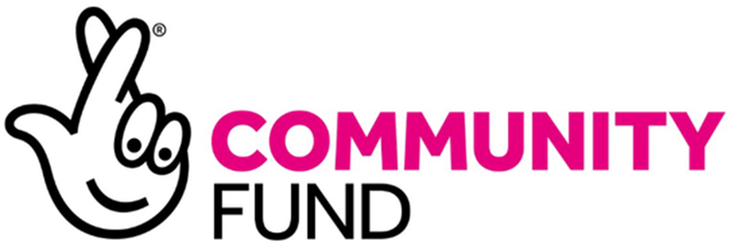

The Bromley and Lewisham Covid-19 Grant Giving Scheme
Frequently Asked Questions
This is a live document which is being updated as we receive questions from our community groups and organisations. If you have questions, please email them to fdo@communitylinksbromley.org.uk

Q1. Can an organisation apply for more than one grant?

A1. No. However, organisations can re-apply if unsuccessful in the first round and if there is available funding.

Q2. There are quite a few 250-word questions. Would the expectation be to reach the total word count for each?

A2. No, not necessarily. The important thing is to ensure that you have provided a concise response to each question, covering all the elements of the question. We would expect applications for larger grants to provide more detail.

Q3. My group focuses on people with mental health issues, rather than another disability. Can I still apply?

A3. Yes, it is well evidenced that poor mental health is a key issue during Covid. You will also find that your project may well fit into some of the other/subsidiary priorities anyway.

Q4. How do I evidence Needs?
A4. This will depend on your project. You may want to show evidence that is internal (e.g a survey), external (e.g a report) or thematic (e.g a report on older people’s care/domestic abuse). This is a Bromley/Lewisham fund so there may be local needs you can evidence as well as evidence for further afield.
Evidence of need can be demonstrated in several ways. One example is to gather information from your service users who are in need of the support that you plan to provide in your area. Another way is to obtain local official data which can highlight particular challenges within your area. You can view local data sets for Bromley via our resources page Resources - Community Links Bromley and Resources - Community Links Bromley and for Lewisham via Lewisham's Joint Strategic Needs Assessment (JSNA) | Lewisham's Joint Strategic Needs Assessment (lewishamjsna.org.uk)

Q5. What is an Outcome?
A5. Outcomes are: ‘The changes, benefits, learning or other effects that result from what the project or organisation makes, offers or provides.’
https://www.inspiringimpact.org/what-is-impact-practice/

Q6. What would be a reasonable percentage used for overheads and management costs?

A6. We did not specify a percentage for management costs as it will be very individual to each organisation. We would rather see an application that honestly and transparently sets out your management and overheads with a narrative if it requires context.

Q7. What happens if I am successful in my grant application and cannot run the project on schedule due to Covid restrictions? Can they defer spending my grant?

A7. The National Lottery Community Fund have said funding not spent needs to be returned to the Lottery. You should aim to complete the project by 28 October 2022.

Q8. Do you have to apply for the full £10k or £20k grant?

A8. No. You can apply for any amount up to £10,000 if you are an unincorporated association/organisation or up to £20,00 for all other eligible groups that meet the criteria.

Q9. Will you fund development projects as well?

A9. Yes. Each application will be considered on merit, therefore if we receive a high-quality application for a development grant which demonstrate good evidence of need and good target outcomes, then it will be considered.

Q10. Do we need to include a Covid risk assessment with our application?

A10. No, this is not a requirement on the application form. It would be helpful to include any Covid considerations in your project summary to show that you have thought about it. We may ask you about how you have adapted due to Covid guidelines/restriction during a monitoring visit. Essentially, it is your responsibility to ensure that you are operating your services within the Covid guidelines/restrictions that exist at any given time.

Q11. We do not have a safeguarding policy. What help is available to draft one?

A11. The National Lottery has a webpage that provides guidance on what it expects of its grant holders.You can see it here, National Lottery Community Fund – Policy for grantholders | The National Lottery Community Fund (tnlcommunityfund.org.uk)

Q11. Can an organisation apply for funding if they have The National Lottery Community Funding or Big Lottery funding already?

A11. Yes, provided that it is not double funding for the same work.

Q12. Our organisation is right on the border of two boroughs, including Bromley/Lewisham. Can we apply?

A12. Yes, but you need to make sure that you provide evidence that you have a track record of working in Bromley/Lewisham boroughs and that the funding would benefit Bromley/Lewisham residents.

Q13. Our organisation delivers in both Bromley and Lewisham. Which form should we complete?

A13. You can complete the form that you feel represents your organisation best. You might plan to reach more beneficiaries in one borough. If the numbers are similar, then you might want to choose the borough where you are physically based.

Q14. Can the grants be used for capital goods e.g., furniture?

A14. Yes. If you are seeking funding for refurbishment or other works then you should go through a tendering process and obtain several estimates to ensure that the work meets your specifications and that the costs are in line with market rates.

Q15. What type of budget information do you require?

A15. The budget template provides headings and examples of the types of expenditure we would expect to see. For example, try and set out staff numbers and whether they are full or part time, what volunteer costs might be expected, together with other overheads and how you have arrived at those figures.

Q16. What is the easiest way to ensure that I do not go over my 250-word limit?

A16. We suggest that you write your longer answers in Word and use the Word Count in the Review tab or try out this useful tool Word Counter Word Counter | Word Count Tool

Q17. Do you give feedback on unsuccessful applications?

A17. Yes. We will give feedback, but it will be limited, due to time constraints. If you have any specific concerns, please contact fdo@communitylinksbromley.org.uk if you have submitted to Bromley or dawn.muspratt@googlemail.com if you submitted to Lewisham.
As part of the programme, we also hope to be able to deliver further support to help you identify other funding options and to improve your bid writing.

Q18. Will I be able to see the terms and conditions of any offer before I apply?

A18. Yes. We have posted a pdf of a typical offer letter and terms and conditions on the scheme’s portal page. Bromley and Lewisham Covid-19 Grant Giving Scheme - Community Links Bromley

Q19. Our organisation operates with Head Office at a national level. We have one bank account, and one set of governing documents are shared between the national organisation and our local projects. We would like to know if this might be an issue.

A19. In principle no. We will want to know that the funding and expenditure can be managed safely within a single account and may ask to see the protocols to ensure that happens.

Q20. How is the assessment panel constructed?
A20. The 2 panels (one for Bromley and one for Lewisham) will be made up of diverse range of representatives from both Community Links Bromley and Blueprint for All plus additional representatives from local organisations and the local authority.

Q21. What happens if my project continues past 28 October 2022?

A20. We expect the organisation to have spent the grant awarded for the project and achieved the outcomes contained within the successful application by the 28 October. If the project can continue through additional alternative funding from other sources, that is fine.

Q22. Will local organisations have priority over larger national organisations?

A22. No, the process is open to all not-for-profit organisations that meet the eligibility criteria on an equal basis. Smaller community-based organisations should highlight their connections and track record in the appropriate sections of the application to evidence the local social value aspect.

Q23. Why are you are holding back 10% of the grant until the end of the project?

A23. We will process 50% of the award on acceptance of the grant offer and the terms and conditions. A further 40% will be released at the midway point of the project, subject to satisfactory progress being shown in the monitoring report. The remaining 10% will be paid at the successful completion of the project. If the timing on the final payment is likely to cause serious issues, especially for small groups or those in receipt of smaller grants, we will be happy to discuss this with you at the appropriate time.

Q24. Will we be able to apply for a grant for a project that we are already delivering?

A24. Yes. However, you will need to demonstrate why the funding is necessary. This could be because of a reduction in funding during the pandemic which has seriously impacted on your ability to deliver to those priority groups, or you have identified additional needs, demand or different ways of delivery.

